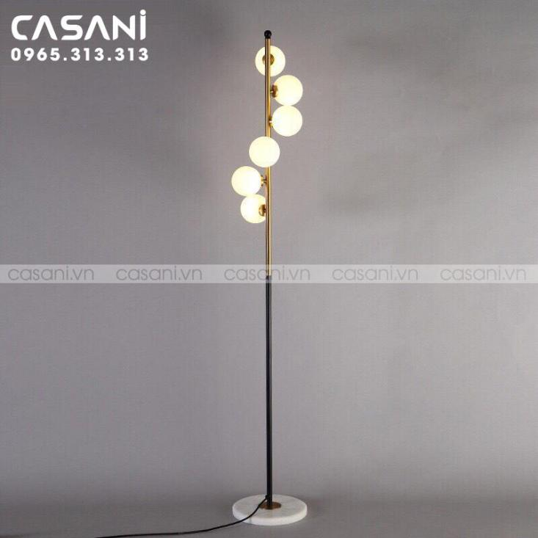

$99.33

- Product name: Decorative floor lamp

- Product code: DDC-2097

- Material: Natural stone base, alloy body

- Design: modern

- Size: Lamp height 1m60, diameter of each ball 12cm

- Bulb type: LED or incandescent (can be easily purchased on the market)

- Status: In stock

- Warranty: 12 months

- Application: living room decoration, bedroom, interior decoration,...